Collections in C#
Why do we need Arrays in programming?
As we know a primitive type variable such as int, double can hold only a single value at any given point in time. For example, int no = 10;. Here the variable “no” holds a value of 10. As per your business requirement, if you want to store 100 integer values, then you need to create 100 integer variables which is not a good programming approach as it will take lots of time as well as your code becomes bigger. So to overcome the above problems, Arrays in C# are introduced.
Types of Arrays in C#:
C# supports 2 types of arrays. They are as follows:
- Single dimensional array
- Multi-dimensional array
In the Single dimensional array, the data is arranged in the form of a row whereas in the Multi-dimensional arrays in C# the data is arranged in the form of rows and columns. Again the multi-dimensional arrays are of two types

- Jagged array: Whose rows and columns are not equal 3,5
- Rectangular array: Whose rows and columns are equal

Memory Representation of Arrays in C#:
Please have a look at the following diagram:
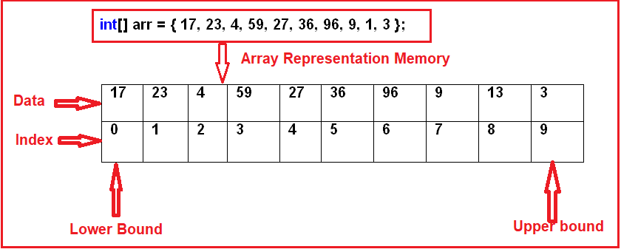

In C#, the arrays can be declared as fixed-length or dynamic. The Fixed length array means we can store a fixed number of elements while in the case of the dynamic array, the size of the array automatically increases as we add new items into the array.
One Dimensional Array in C# with Examples:
The array which stores the data in the form of rows in a sequential order is called a one-dimensional array in C#. The syntax for creating a one-dimensional array in C# is given below.
EXAMPLE
Table of 2
class Program
{
static void Main(string[] args)
{
int j, n;

Console.Write("\n\n");
Console.Write("Display the multiplication table:\n");
Console.Write("-----------------------------------");
Console.Write("\n\n");

Console.Write("Input the number (Table to be calculated) : ");
n = Convert.ToInt32(Console.ReadLine());
Console.Write("\n");
for (j = 1; j <= 10; j++)
{
Console.Write("{0} X {1} = {2} \n", n, j, n * j);
}
}
}

The Array class in C# is not a part of the System.Collections namespace. It is a part of the System namespace. But still, we considered it as a collection because it is Implements the IList interface. The Array class provides the following methods and properties:
- Sort(<array>): Sorting the array elements
- Reverse (<array>): Reversing the array elements
- Copy (src, dest, n): Copying some of the elements or all elements from the old array to the new array
- GetLength(int): A 32-bit integer that represents the number of elements in the specified dimension.
- Length: It Returns the total number of elements in all the dimensions of the Array; zero if there are no elements in the array.

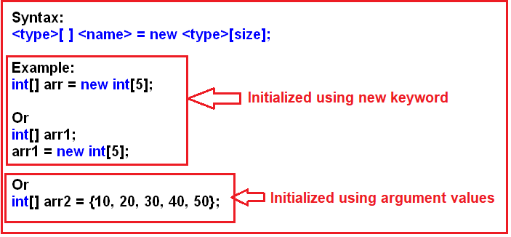
What is a Two-Dimensional Array in C#?
The arrays which store the elements in the form of rows and columns are called Two-Dimensional Array in C#. The two-dimensional array which is also called multidimensional array is of two types in C#. They are as follows
- Rectangular array: The array whose rows and columns are equal are called a rectangular array
- Jagged array: The array whose rows and columns are not equal are called a jagged array
EXAMPLE
class Program
{
static void Main(string[] args)
{
int[] arr = { 14, 15, 23, 4, 56, 67, 43, 23, 28, 12 };
Console.WriteLine("the arre cotain the below element");
for(int i=0;i<arr.Length;i++)
{
Console.WriteLine(arr[i] + "");

}
Console.WriteLine();
// Array.Copy(arr, brr, 5);

int[] brr = new int[10];
Console.WriteLine("the new array element are ");
Array.Copy(arr, brr, 5);
Console.WriteLine("the array element after sorting");
foreach(int i in arr)
{
Console.WriteLine(i + "");

}

// Array.Copy(arr, brr, 5);

foreach (int i in brr)
{
Console.WriteLine(i + "");
}

}
}
}

What are the Array and their disadvantages in C#?
In simple words, we can say that the Arrays in C# are the simple data structure that is used to store similar types of data items in sequential order. Although the arrays in c# are commonly used, they have some limitations.
For example, you need to specify the array’s size while creating the array. If at execution time, you want to modify it that means if you want to increase or decrease the size of an array, then you need to do it manually by creating a new array or by using the Array class’s Resize method, which internally creates a new array and copies the existing array element into the new array.

Following are the limitations of Array in C#:
- The array size is fixed. Once the array is created we can never increase the size of an array. If we want then we can do it manually by creating a new array and copy the old array elements into the new array or by using the Array class Resize method which will do the same thing means to create a new array and copy the old array elements into the new array and then destroy the old array.
- We can never insert an element into the middle of an array
- Deleting or removing elements from the middle of the array.
To overcome the above problems, the Collections are introduced in C# 1.0.

What is a Collection in C#?
The Collections in C# are a set of predefined classes that are present in the System.Collections namespace that provides greater capabilities than the traditional arrays. The collections in C# are reusable, more powerful, more efficient and most importantly they have been designed and tested to ensure quality and performance.
So in simple words, we can say a Collection in C# is a dynamic array. That means the collections in C# have the capability of storing multiple values but with the following features.
- Size can be increased dynamically.
- We can insert an element into the middle of a collection.
- It also provides the facility to remove or delete elements from the middle of a collection.
The collection which is from .Net framework 1.0 is called simply collections or Non-Generic collections in C#. These collection classes are present inside the System.Collections namespace. The example includes are Stack, Queue, LinkedList, SortedList, ArrayList, HashTable, etc.
What is ArrayList in C#?
The ArrayList in C# is a collection class that works like an array but provides the facilities such as dynamic resizing, adding, and deleting elements from the middle of a collection. It implements the System.Collections.IList interface using an array whose size is dynamically increased as required.
Methods and Properties of ArrayList Collection class in C#:
The following are the methods and properties provided by the ArrayList collection class in C#.
- Add(object value): This method is used to add an object to the end of the collection.
- Remove(object obj): This method is used to remove the first occurrence of a specific object from the collection.
- RemoveAt(int index): This method takes the index position of the elements and removes that element from the collection.
- Insert(int index, Object value): This method is used to inserts an element into the collection at the specified index.
- Capacity: This property gives you the capacity of the collection means how many elements you can insert into the collection.
ARRAYLIST CODE
class Program
{
static void Main(string[] args)
{

ArrayList arr = new ArrayList();
arr.Add(10);
arr.Add(200);
arr.Add(400);
arr.Add(200);
arr.Add("Revature");
arr.RemoveAt(3);
arr.RemoveRange(1, 2);
arr.Insert(1, 40);

foreach(object i in arr)
{
Console.WriteLine(i);

}

}

What is the difference between an array and an Array List in C#?
This is one of the frequently asked interview questions in C#. So let us discuss the difference between an array and ArrayList.
Array:
- Fixed Length
- Cannot insert into the middle
- Cannot delete from middle
ArrayList:
- Variable Length
- Can insert an element into the middle of the collectione can access the elements from the collection using a key. That key is nothing but the index position of the elements which is starts from zero (0) to the number of elements – 1. But in reality, it’s very difficult to remember the index position of the element in order to access the values.

- Can delete element from the middle of the collection
Problems with Array and ArrayList Collection in C#:
In the case of Array and ArrayList in C#, wFor example, let’s say we have an employee array that contains the name, address, mobile, dept no, email id, employeeid, salary, location, etc. Now if I want to know the email id or dept no of the employee then it’s very difficult for me. This is because we need to access the value by using the index position. The following example shows this. Here we create a collection using ArrayList and then we are accessing the Location and EmailId by using the index position.
What is a Hashtable in C#?
The Hashtable in C# is a collection that stores the element in the form of “Key-Value Pairs”. The data in the Hashtable are organized based on the hash code of the key. The key in the HashTable is defined by us and more importantly, that key can be of any data type. Once we created the Hashtable collection, then we can access the elements by using the keys. The Hashtable class comes under the System.Collections namespace.
The Hashtable computes a hash code for each key. Then it uses that hash code to look up the elements very quickly which increases the performance of the application
Class HashTable
{
static void Main(string[] args)
{
Hashtable ht = new Hashtable();
ht.Add("eid", 1001);
ht.Add("eid1", 1002);
ht.Add("name", "amit");
ht.Add("Job", "Developer");
ht.Add("Salary", 50000);
ht.Add("location", "delhi");
foreach(object obj in ht.Keys)
{
Console.WriteLine(obj + " :" + ht[obj]);
}
Console.WriteLine("Location" + " :" + ht["location"]);

//Console.WriteLine("is eid key exist or not");
// ht.ContainsKey("eid");
Console.WriteLine("is eid key exist or not" + ht.ContainsKey("r"));
}
}

What is Stack in C#?
The Stack in C# is a non-generic collection class that works in the LIFO (Last In First Out) principle. So, we need to use the Stack Collection in C#, when we need last in first out access to the items of a collection. That means the item which is added last will be removed first. When we add an item into the stack, then it is called pushing an item. Similarly when we remove an item from the stack then it is called popping an item. The Stack class belongs to the System.Collections namespace.
Let us understand the LIFO principle with an example. Imagine we have a stack of plates with each plate added on top of each other. The last plate which is added to the stack will be the first one to remove from the stack. It is not possible to remove a plate from the middle of the stack

STACK EXAMPLE.

class Hash1 {

static void Main(string[] args)
{
Stack st = new Stack();
st.Push("deepti");
st.Push("Amit");
st.Push("ankit");
Console.WriteLine(st.Count);
Console.WriteLine(st.Peek());//display top element without removing it
Console.WriteLine(st.Count);
st.Pop();
Console.WriteLine(st.Count);
st.Pop();
Console.WriteLine(st.Count);
Console.WriteLine(st.Contains("Amit"));
st.Push("Amit");
st.Push("ankit");

foreach (object ob in st)
{
Console.WriteLine(ob);
}
}
}
}

Problems with Non-Generic Collections in C#
The non-generic collection classes such as ArrayList, Hashtable, Stack, and Queue are worked on the object data type. That means the elements are added to the collection are of an object type. As these non-generic collection classes worked on object data type, we can store any type of values that may lead to a runtime exception due to type mismatch. But with Generic Collections in C#, now are able to store a specific type of data (whether a primitive type or a reference type) which provides type safety by eliminating the type mismatch at run time.
The second problem with non-generic collection classes is that we get performance overhead. The reason for this is boxing and unboxing. As we already discussed these collection classes are worked on the object data type. So if we are storing value type data into the collection, then those value type data are first converted into object type and then only store into the collection which is nothing but performing boxing. Similarly, if we want to retrieve the data from the collection, then we need to convert the data from object type to value type means performing unboxing. Due to this boxing and unboxing, we get poor performance if our collection is a big one.
The solution to the Non-Generic Collection Problem
The above two problems of non-generic collections are overcome by the Generic collections in C#. The dot net framework has re-implemented all the existing collection classes such as ArrayList, Hashtable, Stack, and Queue, etc. in Generic Collections such as ArrayList<T>, Dictionary<TKey, TValue>, Stack<T> and Queue<T>. Here T is nothing but the type of values that we want to store in the collection. So. the most important point that you need to remember is while creating the objects of Generic Collection classes, you need to explicitly provide the type of values that you are going to store into the collection.

The Generic Collection classes are implemented under the System.Collections.Generic namespace. The classes which are present in this namespace are as follows.
- Stack<T>,
- Queue<T>,
- LinkedList<T>,
- SortedList<T>,
- List<T>,
- Dictionary<TKey, Tvalue>
Note: Here the <T> refers to the type of values we want to store under them.
Examples:
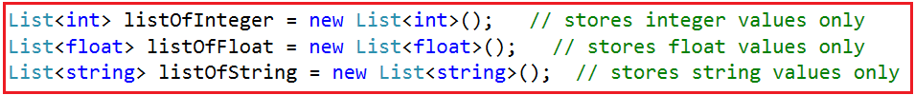
Generic Collections in C#:
The Generic Collections in C# are strongly typed. The strongly typed nature allows these collection classes to store only one type of value into it. This not only eliminates the type mismatch at runtime but also we will get better performance as they don’t require boxing and unboxing while they store value type data.
So, It is always a preferable and a good programming choice to use the Generics Collection Classes in C# rather than using the Non-Generic Collection Classes.

What is Generic List in C#?
The Generic List in C# is a collection class that is present in System.Collections.Generic namespace. The List Collection class is one of the most widely used generic collection classes in real-time applications. This Generic List collection class represents a strongly typed list of objects which can be accessed by using the index. It also provides methods that can be used for search, sort and manipulate the list items.
We can create a collection of any type by using the generic list class in C#. For example, if we want then we can create a list of strings, a list of integers, and even though it is also possible to create a list of the user-defined complex type such as a list of customers, a list of products, etc. The most important point that we need to keep in mind is the size of the collection grows automatically when we add items into the collection.

Methods and Properties of Generic List Collection class in C#:
The following are some of the useful methods and properties of the List collection class in C#.
- Add(T value): This method is used to add an item to the end of the list collection.
- Remove(T value): This method is used to remove the first occurrence of a specific item from the collection.
- RemoveAt(int index): This method takes the index position of the elements and then removes that element from the collection.
- Insert(int index, T value): This method is used to inserts an element into the collection at a specified index position.
- Capacity: This property is used to return the capacity of the collection means how many elements you can insert into the collection.

GENERIC EXAMPLE
public class abc<T>
{

private T Mydata;

public T value
{
get
{
return this.Mydata;
}
set
{
this.Mydata = value;

}
}
class Program
{

public static void Main(string[] args)
{
abc<string> a = new abc<string>();

a.value = "ddepti";
Console.WriteLine(a.value);
}
}
}
}
Generic Example 2
public class abc<T>
{
public T msg;

public string str;
public int d;
public void displaydata()
{
Console.WriteLine("enter name");
str = Console.ReadLine();
Console.WriteLine("enter age");
d = Convert.ToInt32(Console.ReadLine());

Console.WriteLine($"Name:{str}");
Console.WriteLine($"Age:{d}");
}
}

class Program
{

static void Main(string[] args)
{
abc<string> a = new abc<string>();
// abc<int> b = new abc<int>();
// a.name = "Amit";
// b.age = "30";

//Console.WriteLine("enter name");
//string str = Console.ReadLine();
//Console.WriteLine("enter age");
//int d = Convert.ToInt32(Console.ReadLine());

a.displaydata();

}
}

Generic List Example
class Program
{

static void Main(string[] args)
{
List<string> Productlist = new List<string>();
Productlist.Add("Maggi");
Productlist.Add("choclate");
Productlist.Add("cold drinks");
Productlist.Add("toffy");

foreach(var i in Productlist)
{
Console.WriteLine(i);
}

Console.WriteLine($"FirstProduct : {Productlist[0]}");
Console.WriteLine($"secondProduct : {Productlist[1]}");
Console.WriteLine($"thirdProduct : {Productlist[2]}");

}

COMPLEX LIST EXAMPLE
public class employee
{
public int id
{
get; set;
}
public string name
{
get;
set;
}
public string Gender
{
get;
set;
}
public double salary
{
get;
set;
}

}

class Program
{
static void Main(string[] args)
{
employee emp = new employee()
{
id = 101,
name = "amit",
Gender = "male",
salary = 20000

};
employee emp1 = new employee()
{
id = 102,
name = "deepti",
Gender = "Female",
salary = 20

};
List<employee> em = new List<employee>();
em.Add(emp);
em.Add(emp1);

Console.WriteLine("retrieving the first employyee data ");
Console.WriteLine("id={0},name={1},gender={2},Salary={3}", emp.id, emp.name, emp.Gender, emp.salary);
List<employee> em = new List<employee>();
em.Add(emp);
em.Add(emp1);
if (em.Contains(emp1))
{
Console.WriteLine("emp1 exist in object list");
}
else
{
Console.WriteLine("emp1 doesnot exist in object list");
}

if (em.Exists(a => a.name.StartsWith("d")))
{
Console.WriteLine("in list contains employee start with D");
}
else
{
Console.WriteLine("in list does not contains employee start with D");

}

//retrieving all employee data using for loop
for(int a=0;a<em.Count;a++)
{
employee empp = em[a];
Console.WriteLine($"id={empp.id},name={empp.name}gender={empp.Gender},salary={empp.salary}");

}

}
}
}

Dictionary Example 1:-

class Program
{
static void Main(string[] args)
{

Dictionary<string, string> dict = new Dictionary<string, string>();
dict.Add("India", "Delhi,Banglore,Pune,Lucknow");
dict.Add("UK", "Texas,London,Manchester");
dict.Add("US", "new york, Washington");
foreach(KeyValuePair<string,string> k in dict)
{
Console.WriteLine($"Key: {k.Key},value: {k.Value}");
}

for(int i =0; i< dict.Count;i++)
{
string l = dict.Keys.ElementAt(i);
string v = dict[l];
Console.WriteLine($"Key :{l},value:{v}");
}

}
}
}

Dictionary Example
public class employee
{
public int id
{
get; set;
}
public string name
{
get;
set;
}
public string Gender
{
get;
set;
}
public double salary
{
get;
set;
}

}

class Program
{
public static void Main(string[] args)
{
employee emp = new employee()
{
id = 101,
name = "amit",
Gender = "male",
salary = 20000

};
employee emp1 = new employee()
{
id = 102,
name = "deepti",
Gender = "Female",
salary = 20

};
employee emp3 = new employee()
{
id = 103,
name = "deepa",
Gender = "Female",
salary = 20333
};
//List<employee> em = new List<employee>();
//em.Add(emp);
//em.Add(emp1);
//em.Add(emp3);

Dictionary<int, employee> dct = new Dictionary<int, employee>();
dct.Add(emp1.id, emp1);
dct.Add(emp.id, emp);
dct.Add(emp3.id, emp3);

Console.WriteLine("retrieving the first employyee data ");

foreach (KeyValuePair<int, employee> emplkey in dct)
{

//Console.WriteLine("id={0},name={1},gender={2},Salary={3}", e.id, e.name, e.Gender, e.salary);

Console.WriteLine("Key = " + emplkey.Key);
employee emppp = emplkey.Value;
Console.WriteLine("ID = {0},Name ={1} ,gender ={2} ,Salary ={3}", emppp.id, emppp.name, emppp.Gender, emppp.salary);

} }
}
}

